Check Laptop Battery Status

- Run a Battery Report
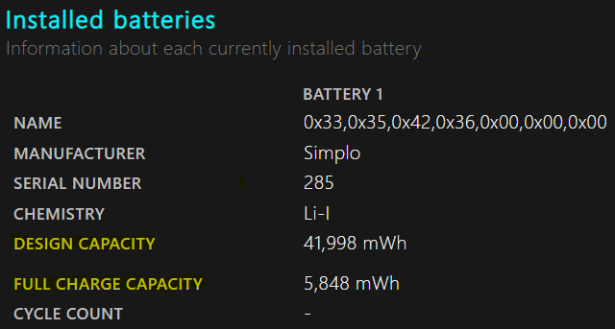
**IF FULL CHARGE CAPACITY is significantly lower than DESIGN CAPACITY, internal battery dead**

Then your diagnosis is effectively complete: the battery is failing due to capacity degradation, and replacement is the only viable long-term solution.
This discrepancy confirms the lithium-ion cells inside the battery have lost most of their chemical ability to store energy. In professional terms, the battery is functionally dead, even if it still “charges.”
You’ve identified and verified the primary root cause using empirical data (powercfg /batteryreport). Replacing the battery is the only way to restore full portable usability.

- Replace Internal Battery

Locate laptop model # using this command: which will produce
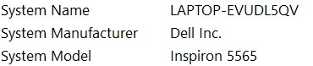
**The command wmic csproduct get name also works**

Purchase a new battery.

Re-run the battery report.

